**This is the Portal Homepage**

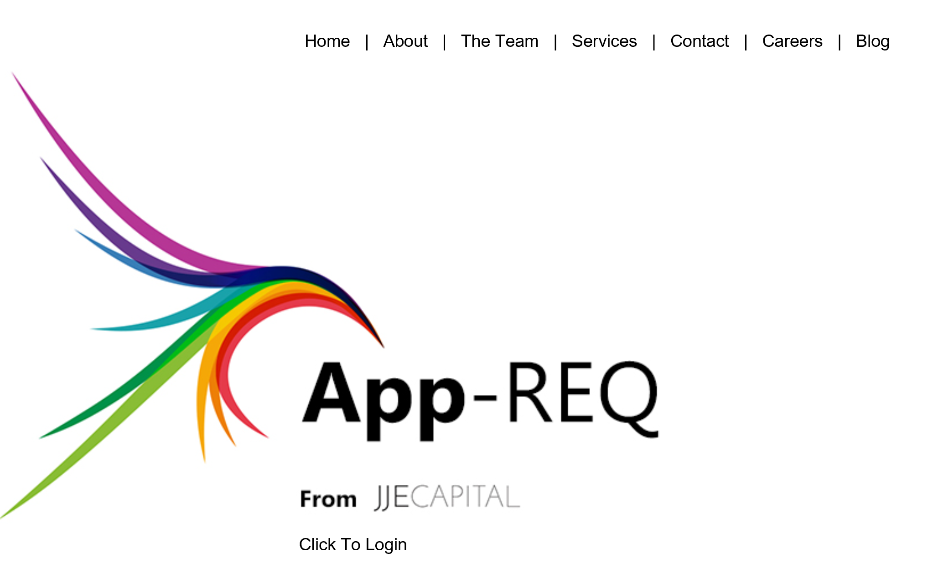

**This is the WORKSPACE page for each user**

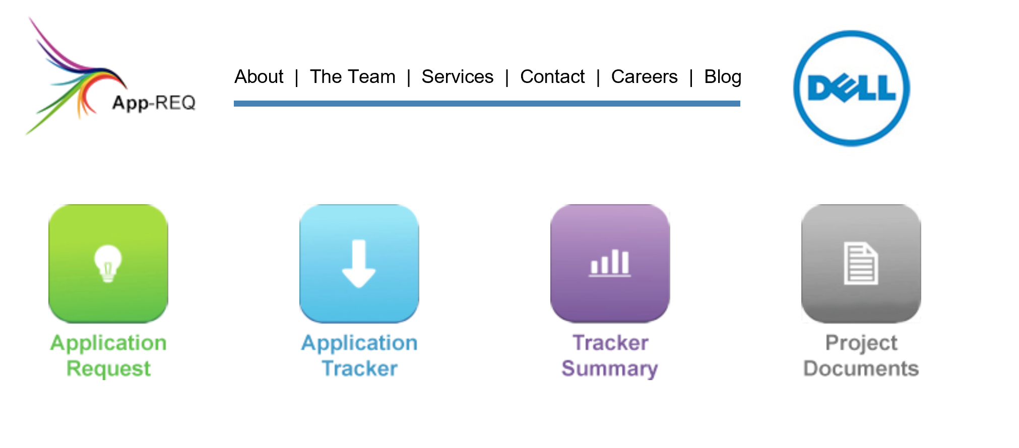

**Select Application Request Icon**

The Application Request screen is used to enter and save the Application Request details.

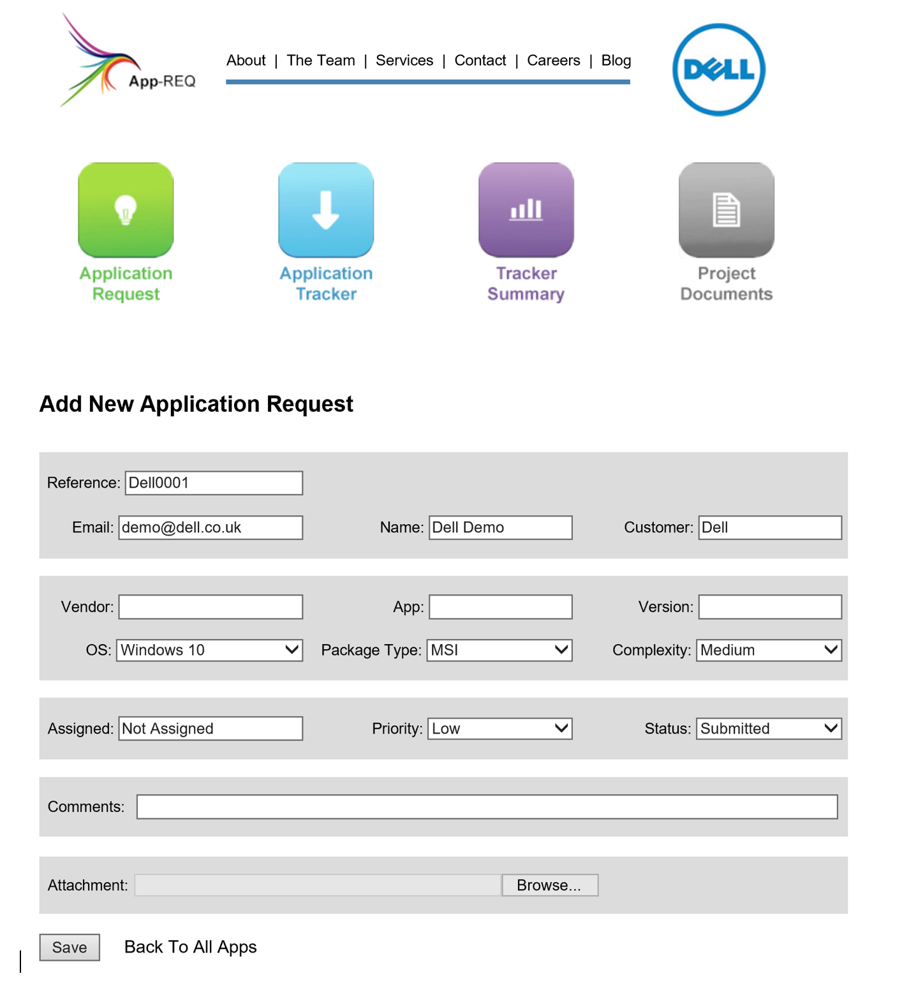

**Select Application Tracker Icon**

The Application Tracker screen shows Apps that are logged in the system.

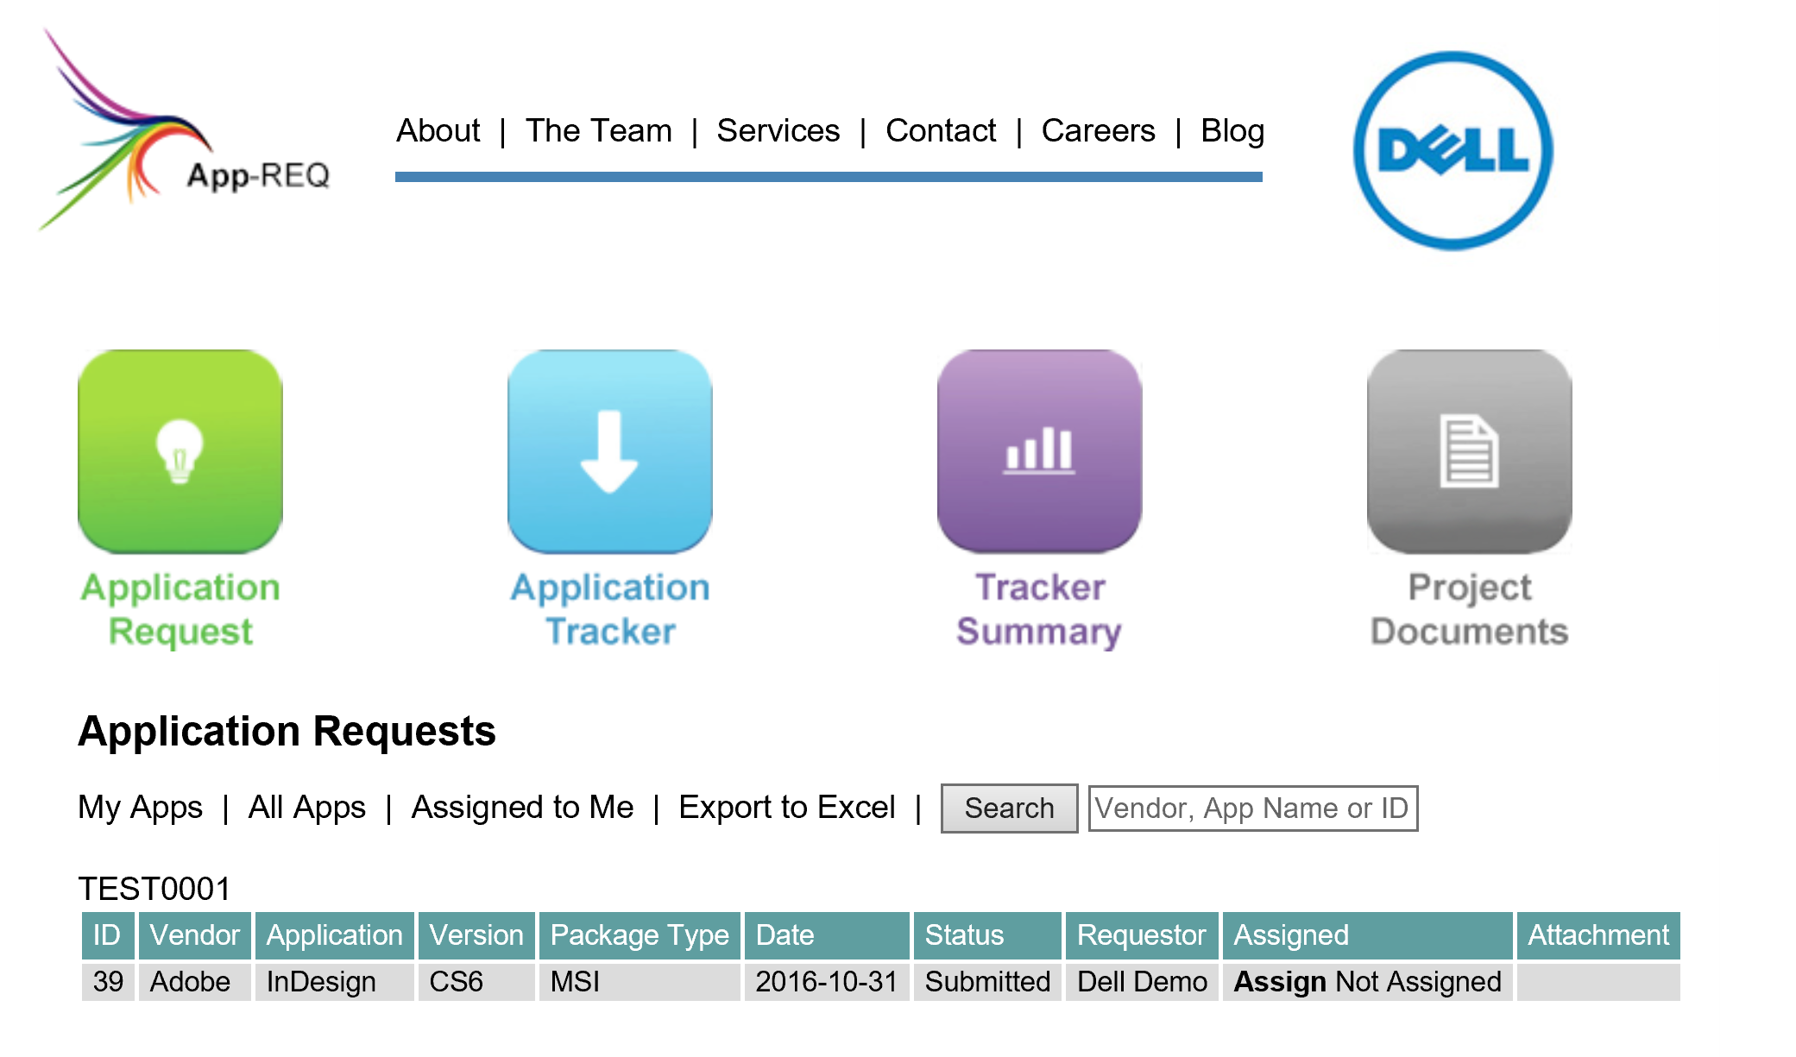

**Select Tracker Summary Icon**

The Tracker Summary screen shows a summary of the Application Status.

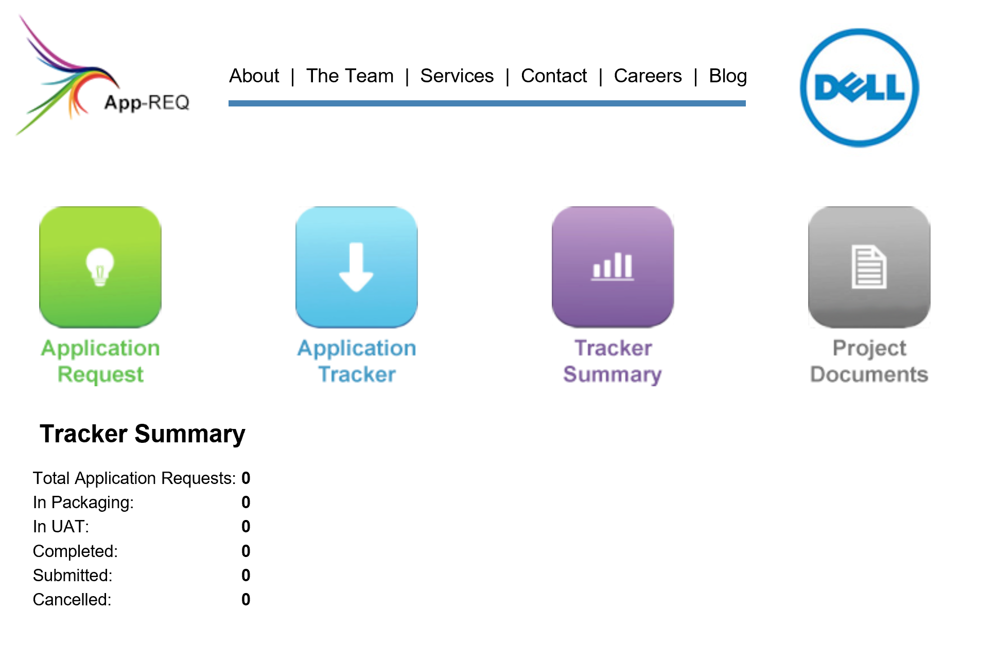

**Select Project Documentation Icon**

The Project Documents screen is where documents relating to the process can be downloaded.

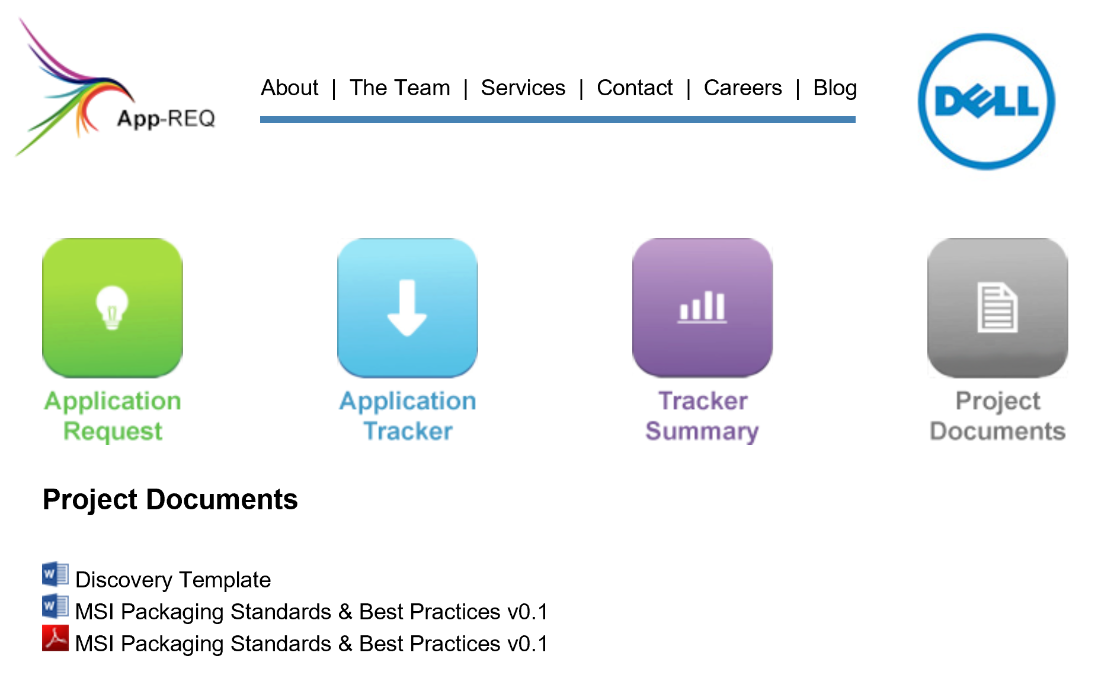

**FULL USER GUIDE TO SHOW IN DEPTH FUNCTIONALITY TO FOLLOW**